Change Makers
Use this list to research a person of your choice
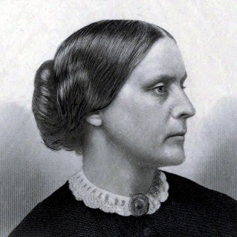 | 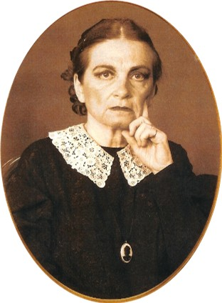 | 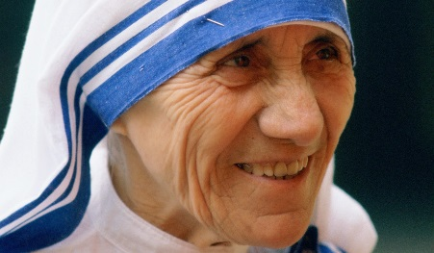 | 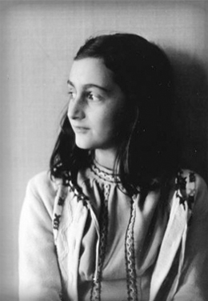 | 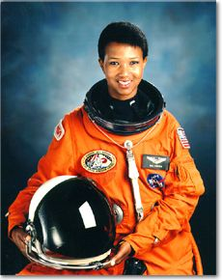 | 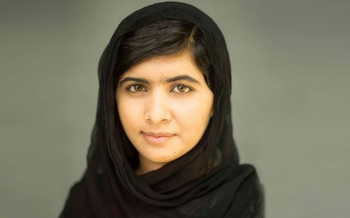
Susan B Anthony  Advocate for Women’s Rights | Dr. Elizabeth Blackwell  First woman to get a medical degree | Mother Teresa  Nun known for international charity work | Anne Frank  Author and victim of Holocaust | Dr. Mae Jemison  First African American female astronaut | Malala Yousafzai  Advocate for girls education
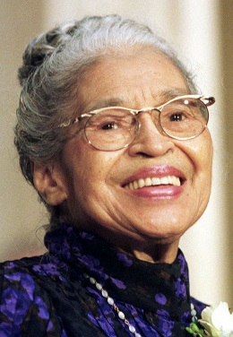 | 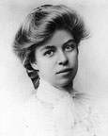 | 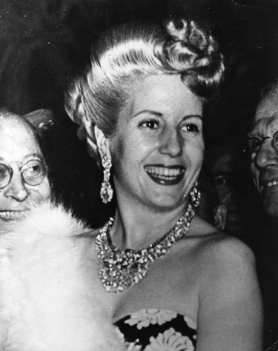 | 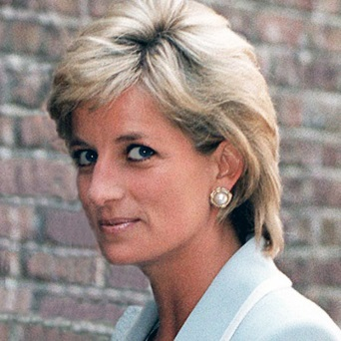 | 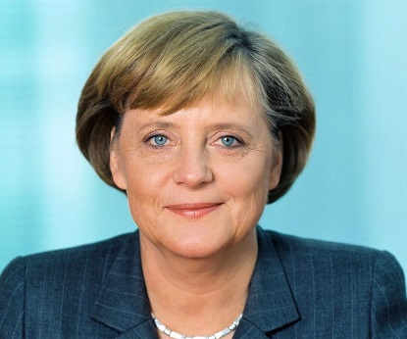 | 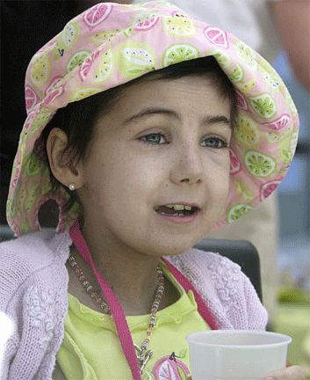
Rosa Parks  Civil Rights Activist | Eleanor Roosevelt  Helped create UN declaration of human rights | Eva Peron  First Lady of Argentina | Princess Diana  Humanitarian | Angela Merkel  2015 Time Magazine Person of the Year | Alexandra Scott  Created Alex’s Lemonade Stand
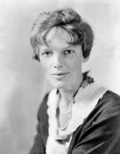 | 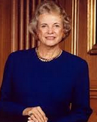 | 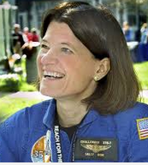 | 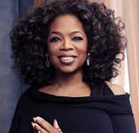 | 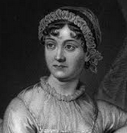 | 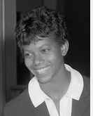
Ameila Earhart | Sandra Day O’Connor  First female Supreme Court Justice | Sally Ride  First female astronaut | Oprah Winfrey  Talk show host | Jane Austin  Female Author | Wilma Rudolf  Athlete and Humanitarian
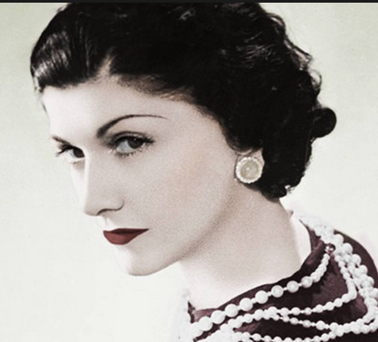 | 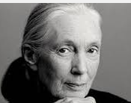 | 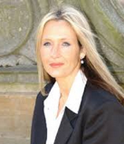 | 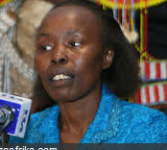 | 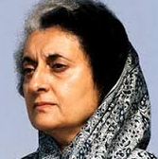 | 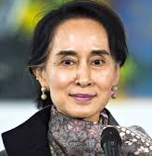
Coco Chanel  Female Fashion designer | Jane Goodall  Environmentalist | J.K Rowling  Successful Author | Tegla Loroupe  Athlete and peace promoter | Indira Gandi  Prime Minister of India | Aung San Suu Kyi  Opposition Leader
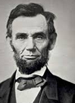 | 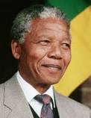 | 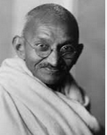 | 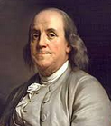 | 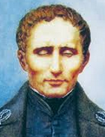 | 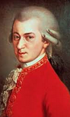
Abraham Lincoln  President Abolish Slavery | Nelson Mandela  Anti-apartheid Leader | Mahatma Gandi  Indian nationalist and politician | Benjamin Franklin  US Writer | Louis Braille  Inventor | Mozart  Austrian music composer

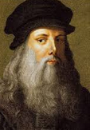 | 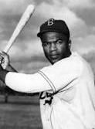 | 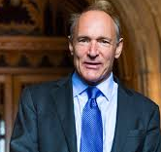 | 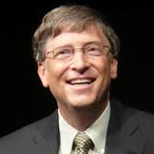 | 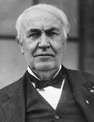 | 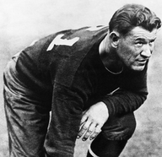
Leonardo da Vinci  Italian scientist and artist | Jackie Robinson  First African American player in Major League | Tim Berners Lee  Founder of the World Wide Web | Bill Gates  Founder of Microsoft | Thomas Edison  Inventor and businessman | Jim Thorpe  Create NFL
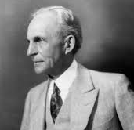 | 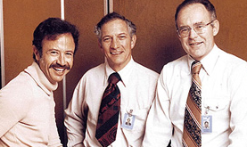 | 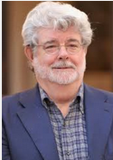 | 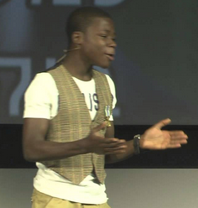 | 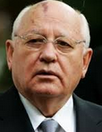 | 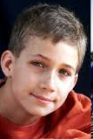
Henry Ford  Industrialist | Jack Kilby and Robert Noyce  Inventors of microchip | George Lucas  Filmmaker | Kelvin Doe  Scientist and inventor | Mikhail Gorbachev  Helped end communism | Ryan Hreljac  Started Ryan’s Well Foundation
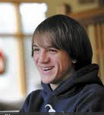 | 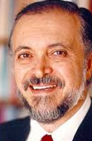 | 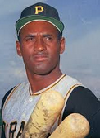 | 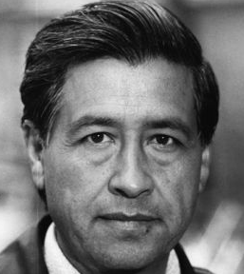 | 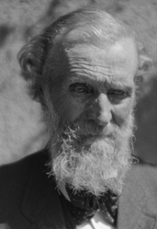 | 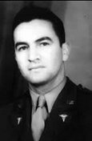
Jack Andrake  Helped find low cost way to detect cancer | Mario Molina  Scientist / Environmentalist | Roberto Clemente  Athlete and Humanitarian | Cesar Chavez  Civil Rights for Farm workers | John Muir  Environmentalist | Hector P. Garcia  Civil Rights Activist

