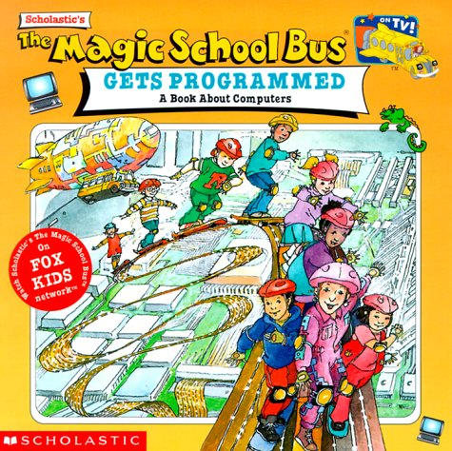 Name

The Magic School Bus Gets Programmed

After you have watched the video list 5 new things that you learned about the computer or how they work.

